Town Hall Meeting
Lake Marcel Community Club
With special guests
King County Councilmember Kathy Lambert,

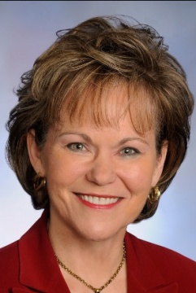

Jerry Blackburn, M.Ed., CDP, Program Manager- Substance Abuse and Prevention Services, Friends of Youth,
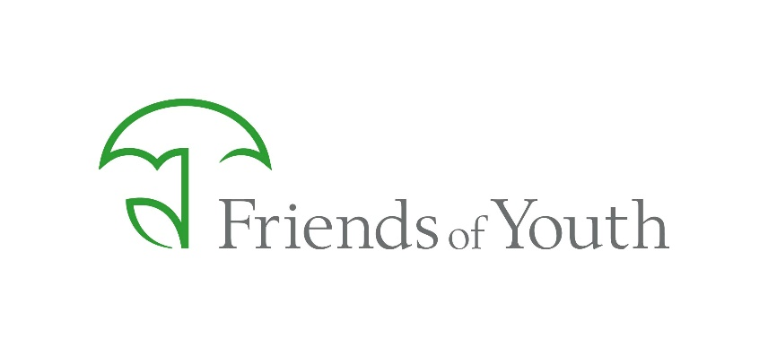
and Representatives from the King County Sheriff’s Office

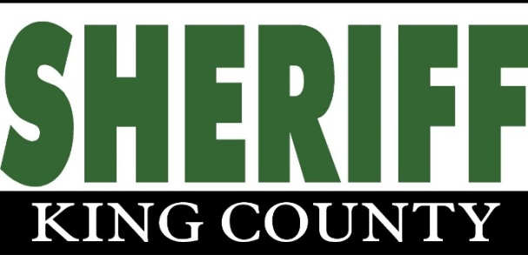

You are invited to attend to find out more about drug and property crimes affecting our community and what YOU can do to protect your home and family.

Saturday, March 19, 2016, 11am – 1pm
Question and Answer session
Carnation Library meeting room
4804 Tolt Ave, Carnation, WA 98014

Drug and Property Crimes – What to Look for and How to Respond
Lake Marcel community members have made ongoing reports of property crimes – break-ins, gas thefts, car prowling, missing packages and stolen mail. Additionally, we have drug crimes – both dealing and using of illegal drugs – occurring within our neighborhood. Your help is needed to stop criminal activity in our neighborhood.
Like other Pacific Northwest communities, our Snoqualmie Valley has been hit hard by heroin and methamphetamine addiction and the associated crimes carried out by addicts. In the past year alone, our neighborhood has seen a drug house raided by a SWAT team, as well as two home invasions in houses bordering our community. Repeat offenders spend short stints in jail, then immediately resume property crimes and illegal drug activities.
Why would gas be stolen when the price of gas is so low? Addicts often put all cash into their habit – even $10 can buy enough drugs to get high, leaving nothing left for filling the tank.
What do illegal drug activities look like?
Watch for suspicious activity:
- Many vehicles stopping by at all hours of the day, or meeting someone at a corner, getting in a vehicle for a short time, then leaving.
- Many visitors staying for a short duration, perhaps arriving empty handed and leaving with a package or backpack.
- Visitors at strange hours, blocked-up windows, and odd smells
- Excessive foot traffic to and from a house, along with loitering in or around a home.
Keep an eye out for drug paraphernalia. Surprisingly, people can be careless about concealing drug paraphernalia such as hypodermic needles and pipes, even when a police presence has been established in the neighborhood. If you see signs of these materials, call the police.
- If you find evidence of drug paraphernalia, take note of where you found it, what type of paraphernalia it was, what time of day you discovered it, and on what date, and report those details to the police. Consider taking a photo.

Examples of Heroin Paraphernalia:
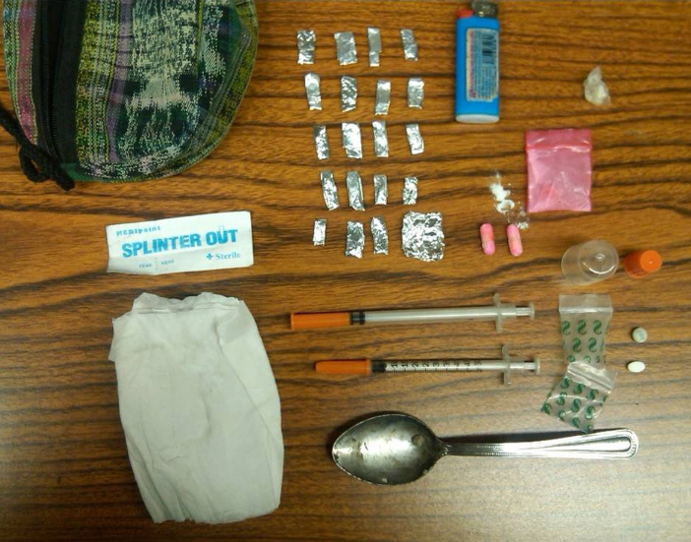
Examples of Methamphetamine / Meth Paraphernalia:
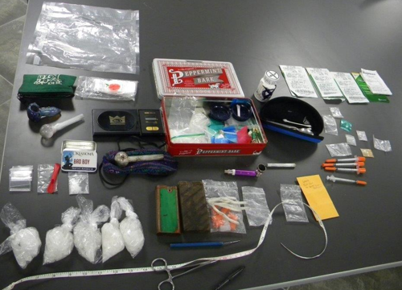
Additionally, “Q-tip” cotton swabs with the cotton removed may be left as trash (the cotton is used as a filter for drug use).
Record as much detail as you can. Always stay safe and don’t approach potential dealers. Gathering details about the activities you observe can help police take the proper action. If the drug dealer lives nearby, you can often document activities from the safety of your own home.
- If you observe suspicious traffic activity, take notes of license plate numbers, car models and colors, and approximate times of visits.
- If you are concerned about a particular individual, write down a detailed description including height, build, hair color, and any identifying features. Also include the circumstances that have caused your suspicion.
- If you feel that the situation is dangerous, be cautious. Do not openly collect information, take photographs, or do other things that might provoke a hostile dealer. Remember: if they are operating in your neighborhood, they may know who you are.
Contact the King County Sheriff at 9-1-1. You can choose to remain anonymous if you will feel safer that way. Provide the police with as much detail as possible about the situation you’ve observed: where you believe drug dealers are operating, what they look like, when their customers come by, how many cars you’ve seen, etc.
- Call from a safe place. Don't place a call where potential dealers can hear or see you. Don't tell suspected dealers that you will call the police.
- Always contact the police and allow them to handle drug activities. Attempting to stop these crimes yourself may cause you or others harm. It may also cause difficulties in prosecuting criminal cases related to the activity later.
- You can call 9-1-1 to report any crime, even a “nonemergency”. Request a case number and request officer contact for follow-up.
- For a crime that is not in-progress and not an emergency, you can report online to the King County Sheriff at http://www.kingcounty.gov/safety/sheriff/ReportToSheriff.aspx
Additionally, report crimes to the LMCC office at 788-2525. LMCC sends out an email alert when crimes are reported.
What happens when you report a crime to the King County Sheriff?
King County Sheriff's Office North Precinct Captain Rodney Chinnick states that when you call 9-1-1 to report a crime, "the response is dictated by the facts and circumstances that are reported by the caller. If, for example, a crime is reported to be in progress because suspects are present, the call will receive a much higher priority response than if this is something that has occurred in the past." When you call, be sure to have details like the location with cross streets (for example, 320th Ave NE and NE 106th St), and details about the vehicle or suspects involved - approximate height, clothing, age, etc.
"If the KCSO receive calls about a problem person or drug house in a neighborhood, then with a caller’s assistance, a Narcotics Activity Report can be completed. Reports can be submitted online or over the phone. Once these reports are generated, they are routed to the appropriate work location, reviewed and assigned for any appropriate follow up."
“If you see something, say something. If that something is a suspicion of an in progress crime, that should result in a call being made to 9-1-1 without delay. We count on our partnership with communities to increase our effectiveness. That works best when community members act as extra sets of eyes and ears for us.” If the concern isn’t a crime in progress, calls can be made to 9-1-1 when convenient. Online reporting is another option in some situations.
Don’t assume someone else will call. We live in a family neighborhood. It’s up to all of us to report crimes to protect our community. Crimes, and reports of crimes, can bring down property values. More importantly, drivers under the influence of illegal drugs pose a risk to pedestrians, pets and children walking home from school.
Please attend the Lake Marcel Community Club Town Hall Meeting with special guests:
King County Councilmember Kathy Lambert A member of the Law and Justice Committee and Criminal Justice Task Force, she works on issues such as gangs, drug abuse and protecting citizens from violent offenders.

Jerry Blackburn, M.Ed., CDP, Program Manager- Substance Abuse and Prevention Services, Friends of Youth will speak on the topics of substance abuse prevention and treatment.

Representatives from King County Sheriff’s Office will also be present to answer your questions on criminal activity and law enforcement.

Question and Answer session following our speakers’ comments.

Saturday, March 19, 2016, 11am – 1pm
Carnation Library meeting room
4804 Tolt Ave, Carnation, WA 98014
Questions? Contact the Lake Marcel Office at 788-2525 or lkmarcel@frontier.net

